Contemplative Fire
Pilgrimage to Now/here

Active Hope in the Climate Crisis

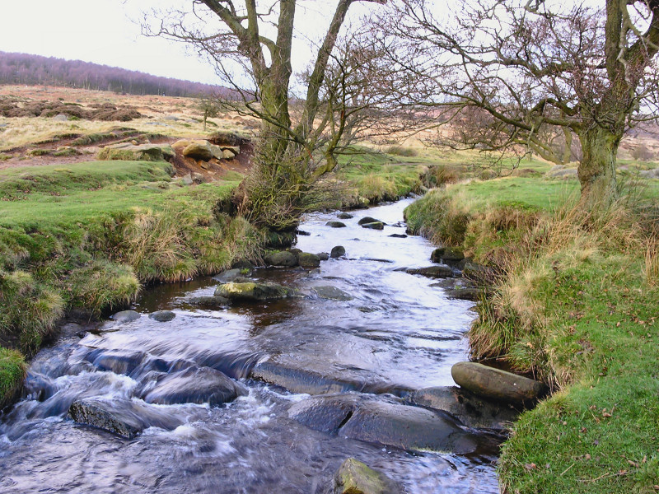
Saturday 1 February 2020 9.30 for 10am until 3.00pm

Led by Contemplative Fire Companions Ali Dorey and Mike Nutt.
There will be a short walk, including some simple body prayer. Our time together will offer opportunities for us to see the reality of climate change with new eyes and find hopeful ways of living in response.

Venue: Longshaw Estate Discovery Centre (next to main car park), S11 7TZ
https://www.nationaltrust.org.uk/longshaw-burbage-and-the-eastern-moors

Each Pilgrimage to Now/here is open to all, so please feel free to bring a friend
You will need a packed lunch and weatherproof wear
Suggested donation for the day, between £10 and £20 per person.

It’s helpful for us to know how many people are coming, so please book by emailing: info@contemplativefire.org (including your name, contact and details of any donation).
Pay by BACS if you can: Contemplative Fire: 78891209 Sort Code: 09-01-27
Reference your payment with “[your surname] PTN”

Or send a cheque made payable to Contemplative Fire to:
Contemplative Fire, The Circle, 33 Rockingham Lane, Sheffield S1 4FW
www.contemplativefire.org Registered Charity no: 1106392

