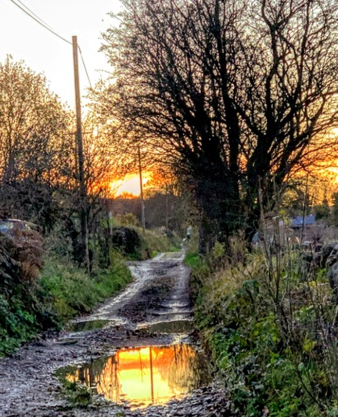
The Art of Noticing
…….Exploring the Inner and Outer World
Leader: Adrian Scott
Programme

Friday 4.00pm onwards Arrivals
6.00pm Evening Meal ( Not silent )
7.30pm Welcome, and introduction AS
…..Move into silence

Saturday 8.30am Breakfast
9.30am Reflection AS
11.00am Coffee Break (silent)
11.20am Reflection AS continued
1.00pm Lunch
2.30pm Optional Silent walk approx. 1 hour
(weather permitting)
Along the route there will be a number of stops with an
Invitation to notice, AS
3.30pm Tea (silent)
4.00pm Reflection AS
Saturday 6.00pm Supper (silent)
Contd. 7.30pm Silent Soiree….. an invitation to share
You are invited, if you wish, to share a short piece/poem you
have written, or which has engaged you written by another.
You may wish to think about this in the days leading up to
the weekend. Pieces to be 2/3 minutes long

Sunday 8.30am Breakfast (silent)
10.00am Mid morning Agape
an informal poetic sharing of bread and wine AS
12.30pm Lunch ( not silent)
2.00pm Depart

