Still Waters – Beautiful Attitudes

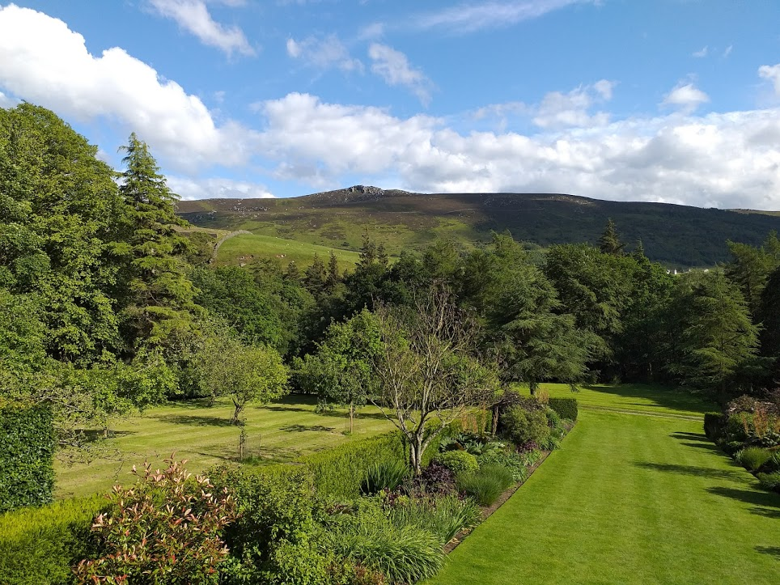

At the CF Retreat recently we looked at the Beatitudes, or Beautiful Attitudes. For this Still Waters I will take a small part of the material we used for a time of reflection and sharing.

Whirlow Spirituality Centre, July 16th, 7.0pm for 7.30.

Please feel free to bring anyone who might be interested. It would be helpful to have some idea of numbers, so please reply to me at jacky@jonjax.net.

