CONTEMPLATIVE FIRE SUMMER WALK
A walk along one of the Peak District’s most beautiful gritstone edges, led by Companion Mike Nutt.
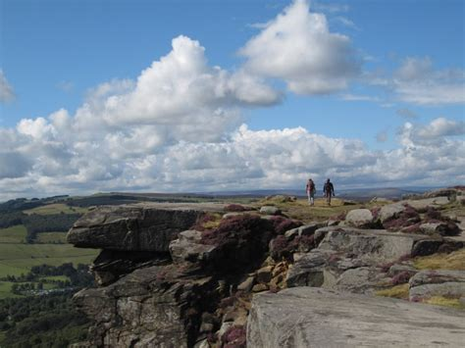
A chance to stretch the legs and share in the company of other companions and friends, with some led reflection stops on the way.
This is not a silent walk in the usual Pilgrimage to Now/Here style.

Where : From Grouse Inn nr. Longshaw, along Froggatt Edge to Curbar Gap and back.
Please note that this walk although mainly flat is a 5 mile walk . There is a refreshment stop (Jolly’s famous tea and coffee van) half-way at Curbar Gap.
Please note there are toilets only at the beginning and end of walk (Grouse Inn )
When : Saturday 6th July . 10.30am start .
Meet in car park of Grouse Inn, Longshaw, Nr Sheffield. S11 7TZ. Note there is parking space along the roadside near the pub .
Booking : It is very helpful to know numbers attending, so please pre-book via Tina Towey . info@contemplativefire.org
Suggested donation for the day, between £10 and £20 per person.

Please pay by BACS if you can. Account name “Contemplative Fire”, sort code 09-01-27, account no. 78891209
Please reference your payment with your surname and CFN pilgrimage
Don’t forget to bring walking shoes/boots , weatherproof clothing, and packed lunch.

