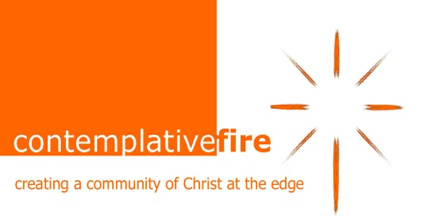
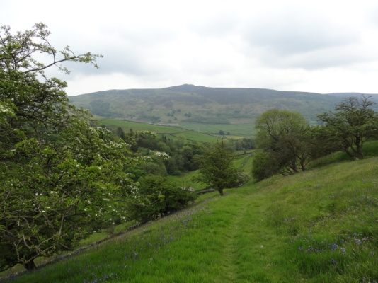
“Beautiful Attitudes”
Songs for a New World

Contemplative Fire Silent Retreat at Parcevall Hall, Appletreewick, Skipton, North Yorkshire, BD23 6DG, 14 – 19 June 2019.
Co-facilitators Ali Dorey and Jacky Stride.

An invitation to spend time with the beatitudes, and deepen our engagement with the landscape, ourselves, others and the Divine. There will be input in the morning, plenty of space for personal reflection, optional activities in the afternoon, and an opportunity to share in Threes.

Parcevall Hall (www.parcevallhall.org.uk) is set in glorious Wharfedale, surrounded by beautiful gardens and countryside, with sounds of birdsong and sheep. There will be opportunity to walk on the moors or by the river, or simply enjoy the amazing RHS Partner gardens.

Ali has been a CF Companion on the Way for about 6 years. She lives in a community household, which aspires to create spaces of prayer and sanctuary in the city. She is an Anglican priest who accompanies people discovering what “church” looks like when it emerges among people who are culturally distant from traditional expressions of church.

Ali enjoys singing in various groups and playing the piano. She writes poetry and theology, and loves going for walks in beautiful landscapes, watching films, doing research on the best local brunch venues and practising contemplation with the help of Xena the household cat.

Jacky has been a Companion on the Way since 2011, and is actively involved in the group in the North. She has 2 adult daughters and 5 grandchildren, all in Sheffield. She divides her time between, amongst other things, family, involvement at Whirlow Spirituality Centre, running the Spiritual Growth and Transformation Course in Sheffield, part of training for spiritual accompaniers, offering spiritual accompaniment, tending an allotment, writing poetry and weight lifting at the gym.

Cost:
The cost of the retreat will be £365 per person, full board, arriving from 4pm on Friday 14th and departing 3pm on Wednesday 19th.

Bursaries:
- Contemplative Fire is able to offer bursaries up to 50% to Companions, if cost is a problem.
- We would like to invite Companions to contribute to our bursary fund to enable others to participate in future events.

To book, please complete the form below and return it to Tina Towey, Contemplative Fire, The Circle, Rockingham Lane, Sheffield S1 4FW by 21st April

Contemplative Fire - Booking form
Parcevall Hall, Appletreewick, Skipton, BD23 6DG, 14th – 19th June, 2019

Yes, I/we wish to book … place(s) on the retreat. Cost: £365 per person.

◻ I have made a BACS transfer/enclose a cheque for my non-returnable deposit of £100 per person

I understand that the balance of £265 is to be paid not later than 14th May 2019

◻ I have made a BACS transfer/enclose a cheque for £365 per person as full payment for the retreat

◻ Please send me a Bursary application form.

◻ My/BACS transfer/ enclosed cheque includes £… as a donation towards the bursary fund

BACS transfers:- Contemplative Fire: sort code 09-01-27 account: 78891209 – identify your payment as PH2019

Cheques:- Please make payable to ‘Contemplative Fire’ and post with your booking form to:-
Tina Towey, Contemplative Fire, The Circle, Rockingham Lane Sheffield, S1 4FW

Name(s) ………………………………………………………………………………………………………………………………

Address ………………………………………………………………………………………… post code ……………………

Email ………………………………………………………………………………………………………………………………………

Tel no ………………………………………………… Mobile ……………………………………………………………………

-Do you have any special dietary needs? ………………………………………………………………………………

-Do you have any medical needs which the retreat leaders should be aware of? …………………

…………………………………………………………………………………………………………………………………………………

-Do you have any special requirements regarding mobility or disability?……………………………………

……………………………………………………………………………………………………………………………………………………….

-Person to contact in case of emergency while you are on retreat:

Name……………………………………………………………………………Relationship to you……………………………..

Phone number……………………………………………….Mobile………………………………………………………………….

