Contemplative Fire Community Fellowship Weekend
at
Mount St Bernard Abbey, Oaks Rd, Coalville, Leicestershire, LE67 5UL

Friday March 8th to Sunday March 10th 2019

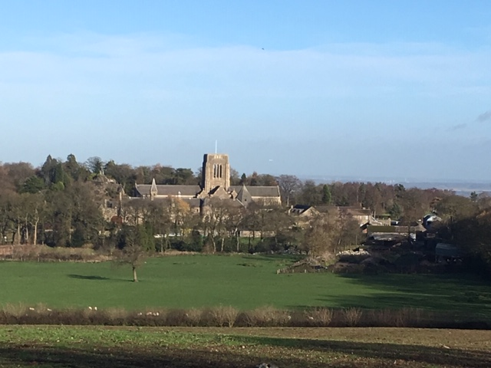

We are excited to offer you an opportunity to join with Companions and friends of Contemplative Fire for our second Community Fellowship Weekend. Set at Mount St Bernard Abbey near Loughborough in the Midlands we hope it will offer reasonable access to all wherever you live and give an opportunity to meet with those in the Midlands who have less opportunity of attending Contemplative Fire events.

The Abbey itself follows the Cistercian rule, which means simplicity and silent contemplation as a path to grow closer to God. They are very interested to hear of different ways of building community, especially a dispersed community such as ours, and have generously offered their hospitality for our weekend.

- Our weekend programme starts on Saturday morning at 9.30, but there is an opportunity to come on Friday night, have a simple meal and enjoy some quiet time in the Abbey guest area and beautiful surrounding hills.

- Saturday will include an optional 8am Tai Chi class in the Abbey grounds; A silent Pilgrimage walk with an opportunity for wild singing; A time to explore praying the Lord’s prayer in Aramaic; A time to share together; A time to be quiet together, and an invitation to join the Abbey community in a short service if we wish. The Abbot also hopes to be able to speak to us if his schedule will allow.

- The food is simple and wholesome and breakfast, lunch and dinner will be offered. The Abbey guest house cannot provide for special diets, but there is a large fridge for guest use, and you are welcome to store any items there. Following Saturday night’s meal, there is an invitation from Companions to take part in lighthearted ‘getting to know you’ activities or to enjoy a time of quiet reflection in the library. You are welcome to bring wine.

- Sunday morning will include an optional Tai Chi class, breakfast, a time of reflection and a Gathering and we will leave after lunch.

- Payment to the Abbey for the weekend is by voluntary donation direct to the Abbey at the weekend, not to Contemplative Fire. The weekend will include up to two nights bed and breakfast, plus two dinners and two lunches if you come on Friday night. We suggest £40 per night as a donation, but pay as you are able, more than this, or less.

- Please note, you are welcome to stay one night or two, but please state how many nights you are booking for when you make your reservation.

- If you prefer you are also welcome to join us just for the day without accommodation. Please reserve a ‘Day Only’ place with Tina below. Cost would be donation for meals only. Arrival from 8 am, depart from 5.30pm or stay for the evening activities.

- The Tai Chi class is by donation to the teacher, Grand Master Woon Lee.

We have booked 14 bedrooms in the Abbey Guest Area and two of these have disabled access. There are a further 7 rooms in the Lodge. We do hope you will be able to take advantage of this new initiative from our Companions.

Best wishes
Contemplative Fire

To reserve a place, please contact Tina, Community Administrator, no later than 9th February by email :-info@contemplativefire.org or telephone 07896 342907,
or by post Tina Towey
Administrator, Contemplative Fire
The Circle, 33 Rockingham Lane
SHEFFIELD S1 4FW

There is an interesting history on the website www.mountstbernard.org

