Saturday’s Silence

“Within listening distance of the silence we call God”

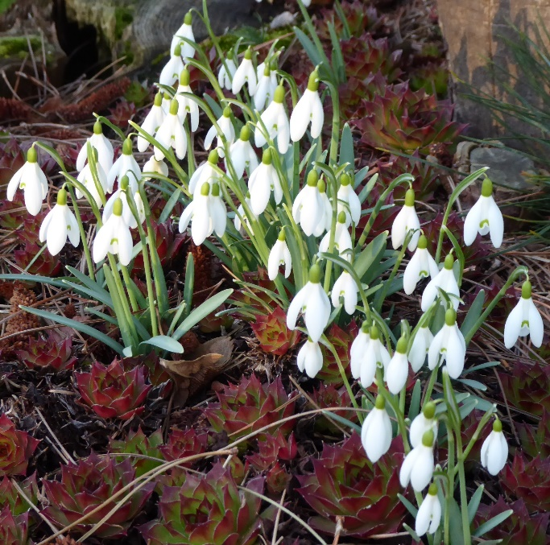

Contemplative Fire Retreat at Holland House,
Main St, Pershore WR10 3NBF
4pm Friday 22nd – 2pm Sunday 24th^{th} Feb 2019

Led by Susan Fogarty and John McEllhenney

Saturday’s Silence, silence kept literally for the whole day and nights either side, allows us to dwell deep in the theme of silence, inspired by the poems of R S Thomas: “But the silence in the mind is when we live best”. You will hear the theme of silence running throughout his poetry; listen to music inspired by his words; look at the art of his wife Elsi Eldridge which ‘speaks to us’ in silence; walk in the natural world, which “looks at us in silence and tells all” with a choice of 7 miles or 2 miles.

Cost: there are 25 single places at a cost of £99 per person, full board, arriving from 4pm on Friday 22nd and departing after lunch on Sunday 24th.

Bursaries:
- Contemplative Fire is able to offer bursaries to Companions if cost is a problem.
- We would like to invite Companions to contribute to our bursary fund to enable others to participate in future events.

To book, please complete and return the form on the next page by email or post.
Please if possible make a BACS transfer or send a cheque for your non-refundable deposit of £45 (or for the total amount of £99), by Monday 10th December 2018 (Address & Payment details below)

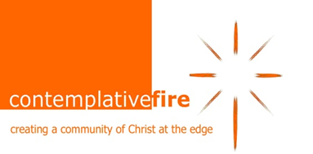
Contemplative Fire Booking Form
Saturday’s Silence Retreat at Holland House.
Friday 22nd – Sunday 24th Feb 2019

Yes, I/we wish to book … place(s) on the retreat. Cost: £99 per person.

Y/N I have made a BACS transfer/enclose a cheque for my non-returnable deposit of £45 per person

I understand that the balance of £54 is to be paid not later than Friday 11th Jan 2019

Y/N I have made a BACS transfer/enclose a cheque for £99 per person as full payment for the retreat

Y/N My BACS transfer/enclosed cheque includes £…... as a donation towards the bursary fund

Name(s)

………………………………………………………………………………………………

Address …………………………………………………………………………………………

Postcode ………………………

Email ……………………………………………………………………………………

Tel no …………………………… Mobile ……………………………………………………

Do you have any special dietary needs?

………………………………………………………………………………………………….

Do you have any medical needs which the retreat leaders should be aware of?

…………………………………………………………………………………………………..

Person to contact in case of emergency while you are on retreat:

Name……………………………………………………………………………

Relationship to you……………………………

Phone number……………… …………………….Mobile…………………………………

Signed ………………………… Date ………….

Return by email to:- info@contemplativefire.org or by post to the address below.

BACS details:- sort code 09-01-27 account no. 78891209. Please identify the payment as HH Retreat.
Cheques:- Please make cheques payable to ‘Contemplative Fire’ and post to:-

Tina Towey, Administrator, Contemplative Fire, The Circle, 33 Rockingham Lane, SHEFFIELD S1 4FW

