‘In Search of My Life’
A day to explore the path of inner transformation
at
Mount St Bernard Abbey , Oaks Rd, Coalville, Leicestershire, LE67 5UL

Saturday August 4th, with optional overnight accomodation.

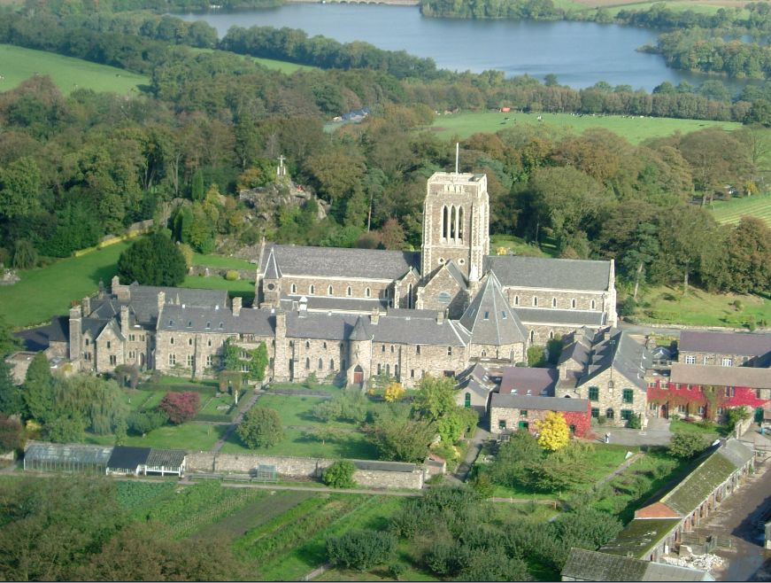

Contemplative Fire is a dispersed community of people across the UK. Some of us have no connection with religious organizations and others belong both to Contemplative Fire and to a church. We have in common a yearning for new and creative ways of encountering the Divine and we respect each other’s unique spiritual journeys. In our own unique way each of us attempts to follow a ‘rhythm of life’ of meditation, learning, and compassionate action.

You are welcome to join a small group of Midlands based Contemplative Fire Companions as we follow a gentle program of silence, reflective walking, and led meditation.

The Abbey itself follows the Cistercian rule, which means simplicity and silent contemplation as a path to grow closer to God, they have generously offered us their hospitality.

- The Saturday program will run from 9.30 to 3.30, but there is an opportunity to come on Friday night, have a simple meal and enjoy some quiet time in the Abbey guest area and beautiful surrounding hills. There is also the opportunity to extend your stay for Saturday night.

- The Saturday program will include a time of led meditation, a Pilgrimage walk, a time to be quiet together, a time to share a simple meal together, and an invitation to join the Abbey community in a short service if you wish.

- For those choosing to stay at the Abbey, the Friday and Saturday nights will be open for you to spend in quiet reflection, or join in peaceful companionship, whatever you wish.

- The food at the Abbey is simple and wholesome and lunch will be provided on Saturday. For those choosing to stay breakfast and dinner will be available.

- Contemplative Fire make no charge for the day. Payment to the Abbey, is by voluntary donation. For a day visitor we suggest £10, and £40 per night as a donation, but pay as you are able, more than this, or less. We would not want financial reasons to prevent attendance. Bursaries are available.

We hope you can join us, and share in the rich experience of our journey together.

Best wishes
Contemplative Fire

To reserve a place, please contact Tina, Community Administrator, by email :-info@contemplativefire.org
or by post Tina Towey
Administrator, Contemplative Fire
The Circle, 33 Rockingham Lane
SHEFFIELD S1 4FW

There is an interesting history on the website www.mountstbernard.org

