Contemplative Fire

Day Pilgrimage in the Hambleden Valley Sunday 19th August 2018
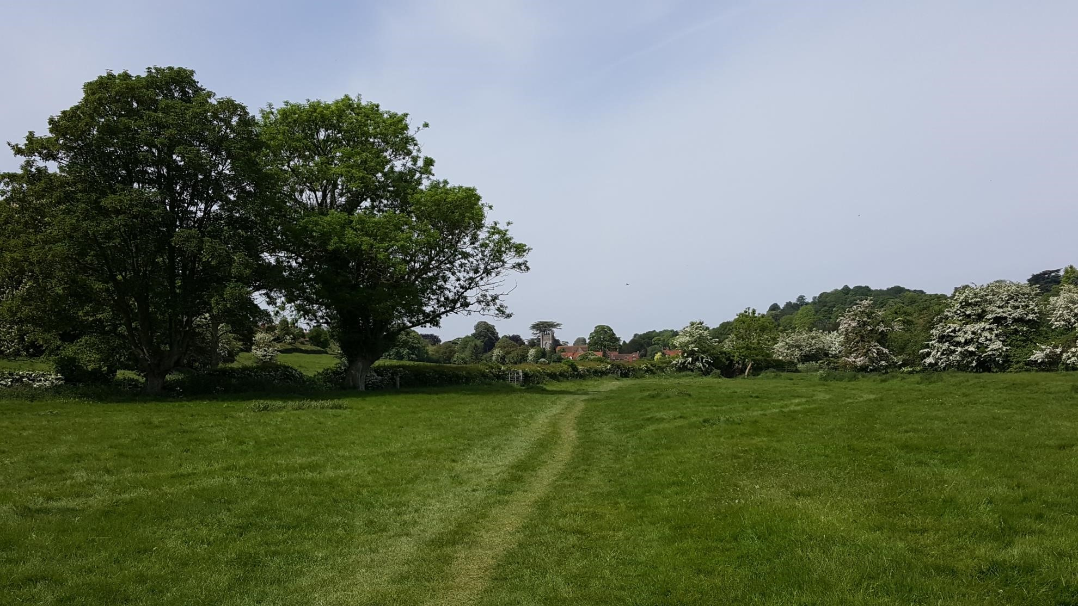
Please do join us for a Day Pilgrimage in the beautiful Hambleden Valley.
This will be a day for walking, chatting, sharing stillness and enjoying a lovely South Buckinghamshire valley with its picturesque villages and ancient churches.
Total walking distance of just over 8 miles (all flat, one stile morning and afternoon) with the option for placing cars at our lunchtime destination and driving on return for those who would like a shorter walk. Pace will be gentle throughout.
Inspired by Tony Mealing’s love of pilgrimage and encouragement of this practice within Contemplative Fire, we have planned a day for Companions, Friends and anyone else who would like to join us. The day will take us from our start point near Mill End, along the Hambleden Valley to our lunchtime destination at the church of St Mary’s Turville. We will then return along the same route, stopping for highly recommended ‘Church Teas’ and exploration of the church at St Mary’s Hambleden in the afternoon.
Both morning and afternoon walks will include time for ‘walking and talking’ as well as sections for walking in silence following a brief led reflection. At lunchtime we will have a led reflection and stillness, followed by time to chat over a packed lunch and explore the church.
Please meet at the Car Park near Mill End from 10am for a prompt departure at 10.30am. The car park gets quite busy on summer weekends, so please do car share where possible. Directions: From the A4155 (which links Marlow and Henley-on-Thames). Travelling from Marlow, after approx. 4.5 miles as you approach Mill End and some houses (30mph area) take a turn right into Skirmett Road, signposted to Fingest, Skirmett and Hambleden and indicating to Car Park 500yds (also a brown sign for Chiltern Valley Winery and Brewery). Car park is on your left but do approach slowly as it can be difficult to spot due to hedges along the roadside. The postcode RG9 6TL is actually for housing further along Skirmett Road, but will get you to the right general area.
Please bring water, a packed lunch and some cash if you wish to join in afternoon tea in Hambleden. There is no charge for the day but we would like to make an offering to our host church if possible. The toilets in the car park are currently closed, so do stop and find facilities before you arrive if you have travelled some distance. There is a toilet which will be opened for our use at our lunch stop church.
As the route is along a river valley, there may be some mud if weather has been wet in the preceding weeks. Please wear suitable walking boots or shoes and bring a waterproof coat if it looks like there may be rain on the day, or sunhat and sunscreen if (as we hope!) it’s going to be sunny.
There is no need for formal booking - we will leave promptly at 10.30am with whoever has arrived and will go ahead whatever the weather. There is only patchy mobile phone signal in the area so we can’t rely on receiving messages about late arrivals etc. However … if you would like to do the shorter walk option we do need to know beforehand as it will involve additional arrangements for arriving earlier and placing the right number of cars at the midway point. You are also welcome to let us know that you are intending to come for the whole walk so we have a rough idea of numbers.
Please contact Jo Howard at jhoward597@gmail.com to register interest or for further information.

